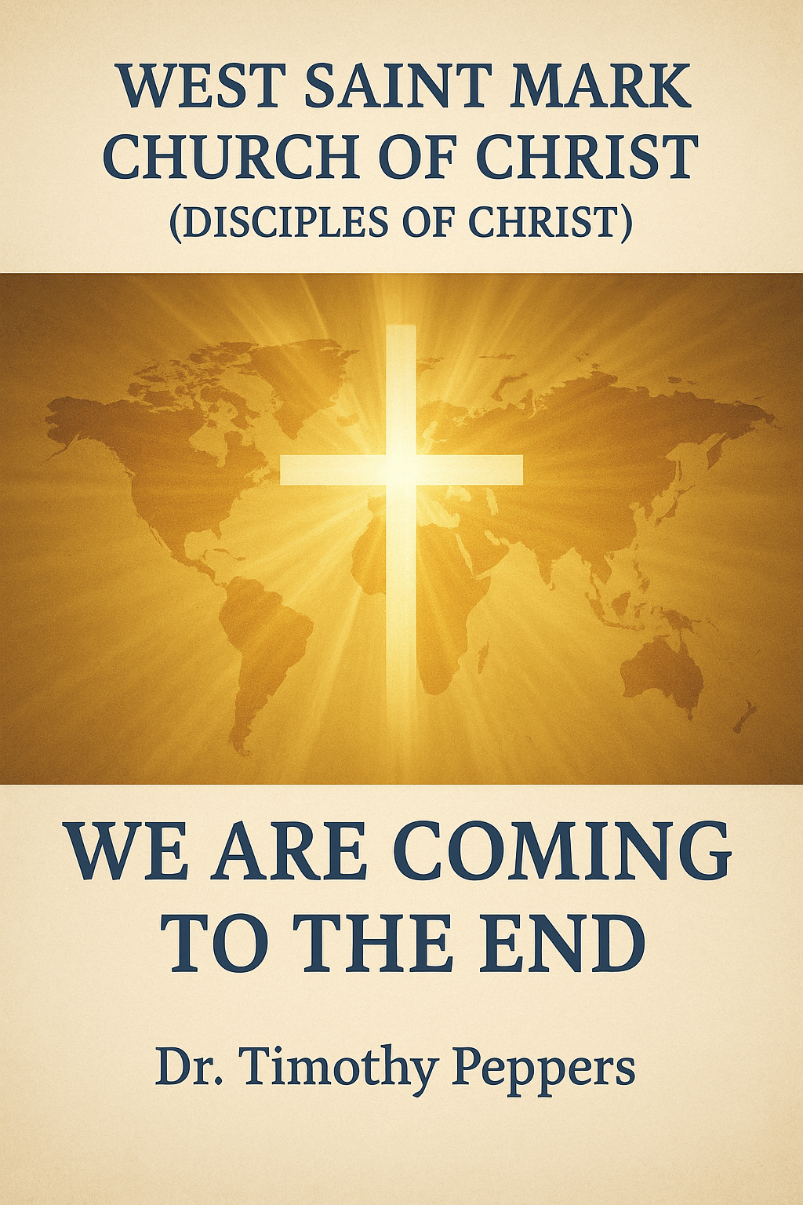

Eschatology
Eschatology is derived from two Greek words: eschatos (last) and logos (study or word). It is the branch of theology concerned with the final events in the history of the world and humankind, including the return of Christ, the final judgment, the resurrection, and the ultimate destiny of the soul and the Church.
1. Eschatology
Eschatology (from Greek eschatos = last, logos = study) is the theological study of the last things, including:
- The Second Coming of Christ
- The Day of the Lord
- The Resurrection of the dead
- Final Judgments
- Restoration of Creation
- The Millennial Reign of Christ
Key Scriptures:
- Acts 1:11 – Christ will return in the same manner He ascended.
- Revelation 20:11-15 – Final judgment of all humanity.
- 2 Peter 3:10 – The heavens and earth will be consumed with fire.

2. Key Terms and Explanations
Term | Meaning | KJV Reference
Rapture | The catching up of believers to meet Christ in the air | 1 Thessalonians 4:16-17
Tribulation | Period of intense suffering before Christ’s return | Matthew 24:21
Millennium | 1000-year reign of Christ on earth | Revelation 20:4-6
Judgment Seat of Christ | Evaluation of believers’ works for rewards | 2 Corinthians 5:10
Great White Throne Judgment | Final judgment of all unbelievers | Revelation 20:11-15
Day of the Lord | A divine day of judgment and salvation | Joel 2:31; 2 Peter 3:10
Restoration | Renewal of creation and humanity | Acts 3:21; Romans 8:19-22

3. Signs of the End Times
- Natural Signs: Earthquakes, famines, pestilence, storms (Matthew 24:7; Luke 21:11)
- Moral and Social Decline: Lawlessness, persecution of believers, deceit (2 Timothy 3:1-5; Matthew 24:12)
- Political Upheaval: Wars and rumors of wars (Matthew 24:6)
- Religious Deception: False prophets and false Christs (Matthew 24:23-25)
- Global Disturbances: Sun, moon, and stars affected (Luke 21:25-26; Revelation 6:12-14)

4. Effects on the Earth and People
- Earthly Effects:
  - Natural disasters intensify (Matthew 24:7)
  - Cosmic disturbances disrupt normal order (Luke 21:25-26)
  - Creation itself groans under corruption (Romans 8:22)
- Effects on People:
  - Fear, confusion, and moral panic (Luke 21:26)
  - Persecution of Christians and increased lawlessness (2 Timothy 3:12)
  - Opportunities for repentance and faith in Christ (2 Peter 3:9)
5. The Judgments
5.1 Believers’ Judgment (Bema Seat)
- Purpose: Reward for faithful service (2 Corinthians 5:10)
- Not for condemnation
5.2 Judgment of Nations
- Separation of the righteous and wicked (Matthew 25:31-46)
- Based on deeds of mercy and justice
5.3 Great White Throne Judgment
- Final judgment of all unbelievers (Revelation 20:11-15)
- Results in eternal separation from God
6. Day of the Lord
- Definition: Time of God’s decisive intervention, marking the end of human history and establishment of Christ’s reign.
- Characteristics: Sudden, universal, involves judgment and deliverance.
- Key Scriptures: Isaiah 13:6-13; Joel 2:31; 2 Peter 3:10

7. Restoration
- Definition: Renewal and healing of creation and humanity
- Scriptural Support: Acts 3:21; Romans 8:19-22
- Features:
  - Earth renewed, free of corruption
  - Righteousness and justice prevail
  - God dwells with His people in peace (Revelation 21:1-4)
8. Reign of Christ (Millennial Kingdom)
- Definition: Christ’s 1000-year reign bringing peace and justice (Revelation 20:4-6)
- Characteristics:
  - Satan bound (Rev 20:1-3)
  - Resurrection of faithful believers
  - Universal knowledge of God (Isaiah 2:2-4)
9. Lecture Notes and Commentary
- Blessed Hope – Motivation for holy living (Titus 2:13)
- Signs of the End Times – Indicators for readiness (Matthew 24:4-14)
- Tribulation and Persecution – Endurance under trials (Revelation 7:14)
- Resurrection – Both righteous and wicked rise (John 5:28-29)
- Eternal State – God dwells with His people; sorrow and death removed (Rev 21-22)
10. Discussion Questions
- How should awareness of end-time signs influence Christian behavior today?
- Discuss the difference between believers’ judgment and the final judgment of the wicked.
- How will global and cosmic disturbances affect life on earth?
- What role does restoration of creation play in God’s plan?
- How can studying eschatology strengthen hope and perseverance in faith?

11. Multiple Choice Questions (Self-Scoring)
- Eschatology is the study of:
  - A) Church history
  - B) End times
  - C) Angels
  - D) Rituals
- The Day of the Lord includes:
  - A) Divine judgment
  - B) Only blessings
  - C) Sabbath observance
  - D) Christ’s first coming
- Signs of the end times include:
  - A) Moral decline, wars, earthquakes
  - B) Only church growth
  - C) Wealth and prosperity
  - D) Silence
- The Bema Seat Judgment is for:
  - A) Nations
  - B) Believers for rewards
  - C) All humanity
  - D) Angels

- The Great White Throne Judgment applies to:
  - A) Unbelievers
  - B) Only believers
  - C) Apostles
  - D) Angels
- Restoration refers to:
  - A) Political control
  - B) Renewal of creation and righteousness
  - C) Personal wealth
  - D) Church construction
- Millennial reign lasts:
  - A) 500 years
  - B) 1000 years
  - C) 50 years
  - D) Indefinite
- Cosmic signs affect:
  - A) Only believers
  - B) Sun, moon, and stars
  - C) Only nations
  - D) Only angels
- Effects on people during end times:
  - A) Fear, confusion, persecution
  - B) Global peace only
  - C) Prosperity only
  - D) No effect

- Ultimate purpose of eschatology:
  - A) Fear of God
  - B) Understanding God’s final plan
  - C) Political influence
  - D) Wealth accumulation

12. Essay Assignment
Write a 150–200 word essay reflecting on:
- How the knowledge of end-time signs and events affects your spiritual priorities
- The hope offered by Christ’s return and restoration of creation
- How understanding eschatology changes your perspective on global and personal challenges

Answer Key: 1-B, 2-A, 3-A, 4-B, 5-A, 6-B, 7-B, 8-B, 9-A, 10-B

