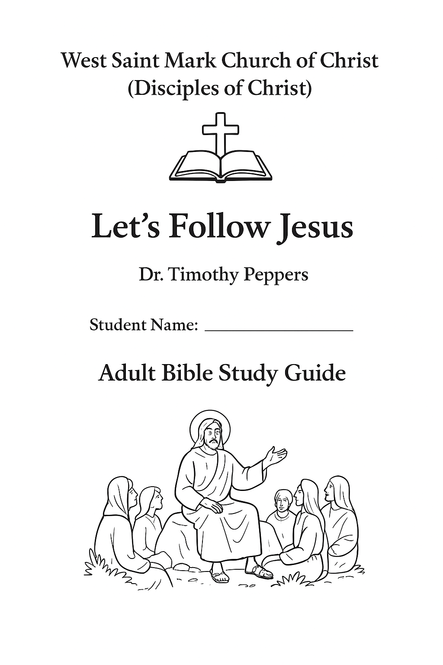

West Saint Mark Church of Christ (Disciples of Christ)
Adult Bible Study Guide
Instructor: Dr. Timothy Peppers
Student Name: _______________________
Title: Let’s Follow Jesus

Table of Contents
- Introduction
- Study Guide Objectives
- Part 1: Northern and Central Galilee
- Part 2: Judea, Samaria, and Surrounding Villages
- Maps & Illustrations

Introduction
This guide explores the geographical towns, cities, and villages that Jesus traveled to during His ministry. Students will examine KJV Bible passages, summarize teachings and miracles, consider the political and seasonal context, and reflect on how these lessons can be applied today.

Study Objectives
- Identify key locations visited by Jesus.
- Summarize the events, teachings, and miracles at each site.
- Analyze cultural, political, and seasonal context.
- Reflect critically and apply lessons to daily life.
- Complete quizzes, discussion questions, and a short essay.

Part 1: Northern and Central Galilee
Locations, KJV References, and Summaries
Location | KJV Reference | Summary of Teaching / Miracle | Season / Political Climate | Timeline
Nazareth | Luke 4:16-30 | Preached Isaiah 61, faced rejection | Early ministry, Roman occupation | 27–28 AD
Capernaum | Matthew 4:13-17; Mark 2:1-12 | Taught in synagogue, healed paralytic | Trade hub | 27–28 AD
Bethsaida | Mark 8:22-26 | Healed blind man | Fishing village | 28 AD
Chorazin | Matthew 11:20-24 | Woes to unrepentant | Small town | 28 AD
Magdala | Luke 8:2 | Mary Magdalene healed | Fishing village | 28–29 AD
Nain | Luke 7:11-17 | Raised widow’s son | Rural village | 28 AD
Mount of Beatitudes | Matthew 5:1-12 | Sermon on the Mount | Hillside | 28 AD
Sea of Galilee | John 6:16-21 | Calmed storm, walked on water | Traveling by boat | 28 AD
Bethsaida Julias | Luke 9:10-17 | Feeding 5000 | Village near Galilee | 28 AD
Cana | John 2:1-11 | Water into wine | Wedding | 27–28 AD

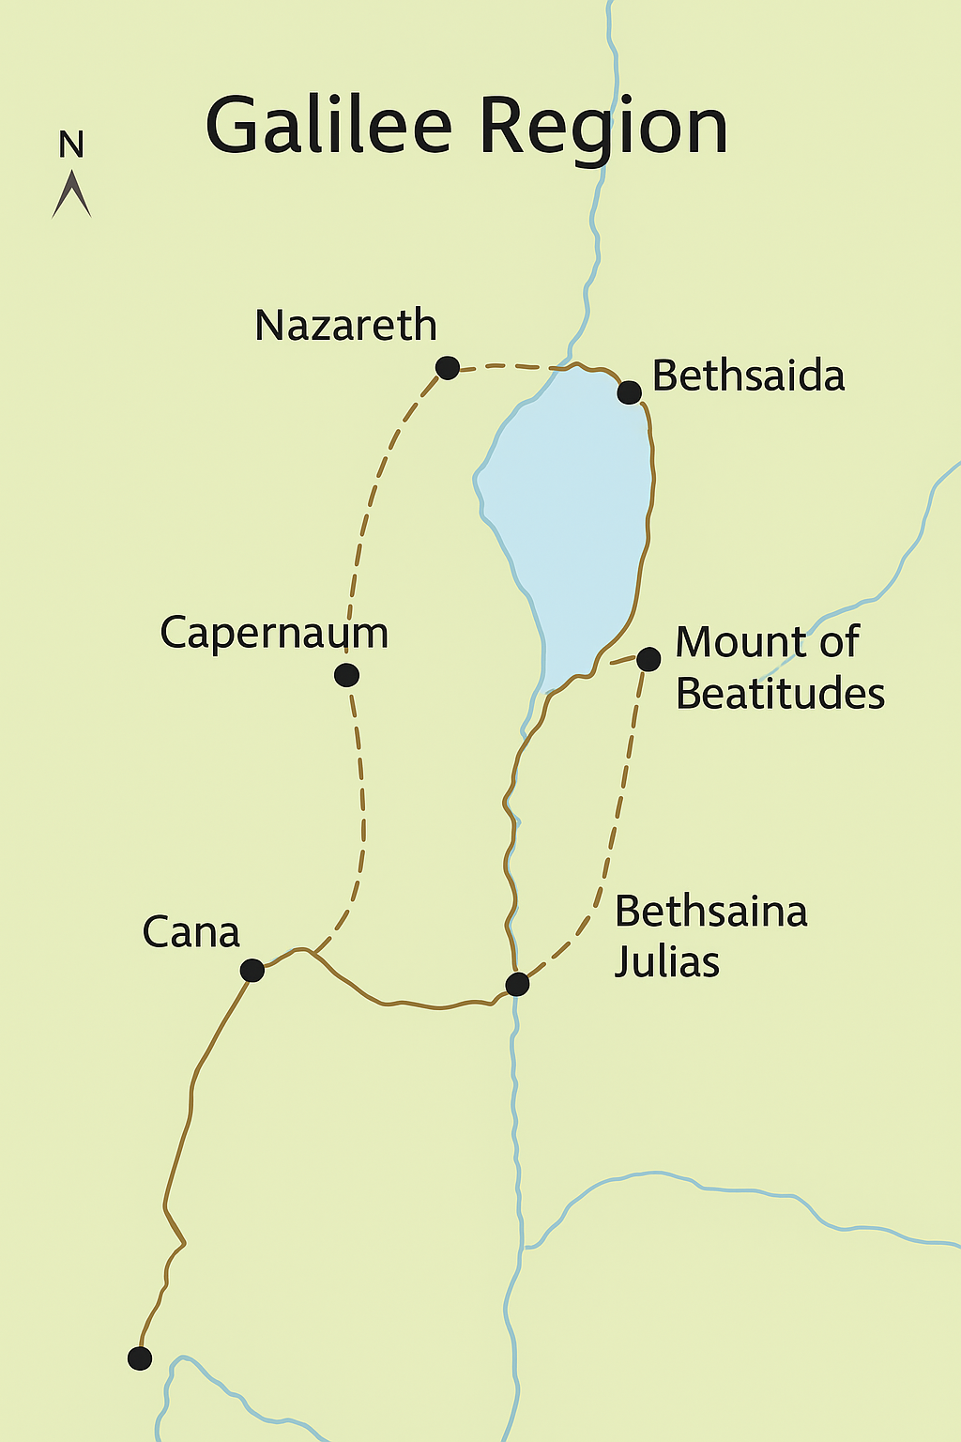
Discussion Questions
- Why did some towns like Nazareth reject Jesus?
- How did geography influence ministry?
- Compare miracles in villages vs. cities.
- Lessons from the Sermon on the Mount.

Part 1 Multiple Choice Questions (Self-Scoring):
- In which town did Jesus read from Isaiah 61 in the synagogue?
  - a) Capernaum
  - b) Nazareth
  - c) Bethsaida
  - d) Nain
- Which city witnessed the healing of a paralytic on a mat?
  - a) Chorazin
  - b) Capernaum
  - c) Magdala
  - d) Cana
- Where did Jesus deliver the Sermon on the Mount?
  - a) Sea of Galilee
  - b) Bethsaida
  - c) Mount of Beatitudes
  - d) Nain
- Which village was Mary Magdalene healed from seven demons?
  - a) Bethsaida
  - b) Magdala
  - c) Cana
  - d) Chorazin
- In which location did Jesus raise a widow’s son?
  - a) Nain
  - b) Nazareth
  - c) Capernaum
  - d) Magdala
- Where did Jesus perform His first miracle?
  - a) Capernaum
  - b) Cana
  - c) Bethsaida
  - d) Chorazin
- Which city received woes from Jesus for their unbelief?
  - a) Nazareth
  - b) Chorazin
  - c) Bethsaida
  - d) Magdala
- Where did Jesus calm the storm and walk on water?
  - a) Sea of Galilee
  - b) Jordan River
  - c) Mount of Beatitudes
  - d) Nain
- Feeding of the 5000 occurred near which town?
  - a) Bethsaida Julias
  - b) Magdala
  - c) Cana
  - d) Chorazin
- Which town did Jesus call His own home in early ministry?
  - a) Cana
  - b) Nazareth
  - c) Bethsaida
  - d) Capernaum

Essay Assignment
Write a 100-word reflection on Jesus’ ministry in Northern and Central Galilee. Focus on locations, lessons, and miracles.

Part 2: Judea, Samaria, and Surrounding Villages
Location | KJV Reference | Summary | Season / Political Climate | Timeline
Jerusalem | John 2:13-25; Matthew 21:12-17 | Cleansed temple, taught | Major city, Roman capital | 28–30 AD
Bethlehem | Matthew 2:1 | Birth of Jesus | Roman occupation | 4–6 BC
Bethany | John 11:1-44 | Raised Lazarus, Mary & Martha | Near Jerusalem | 30 AD
Samaria / Sychar | John 4:4-42 | Woman at the well, salvation | Culturally distinct | 28–29 AD
Jericho | Luke 19:1-10 | Zacchaeus salvation | Wealthy trade town | 29–30 AD
Emmaus | Luke 24:13-35 | Walked with disciples post-resurrection | Near Jerusalem | 30 AD
Gadara/Gerasenes | Mark 5:1-20 | Healed demon-possessed man | Gentile region | 28–29 AD
Cana | John 4:46-54 | Healed nobleman’s son | Galilee | 28 AD
Mount Olivet | Matthew 24:1-3 | Prophecy of end times | Overlooking Jerusalem | 30 AD
Jordan River | Matthew 3:13-17 | Baptism of Jesus | Boundary of Judea/Perea | 27 AD

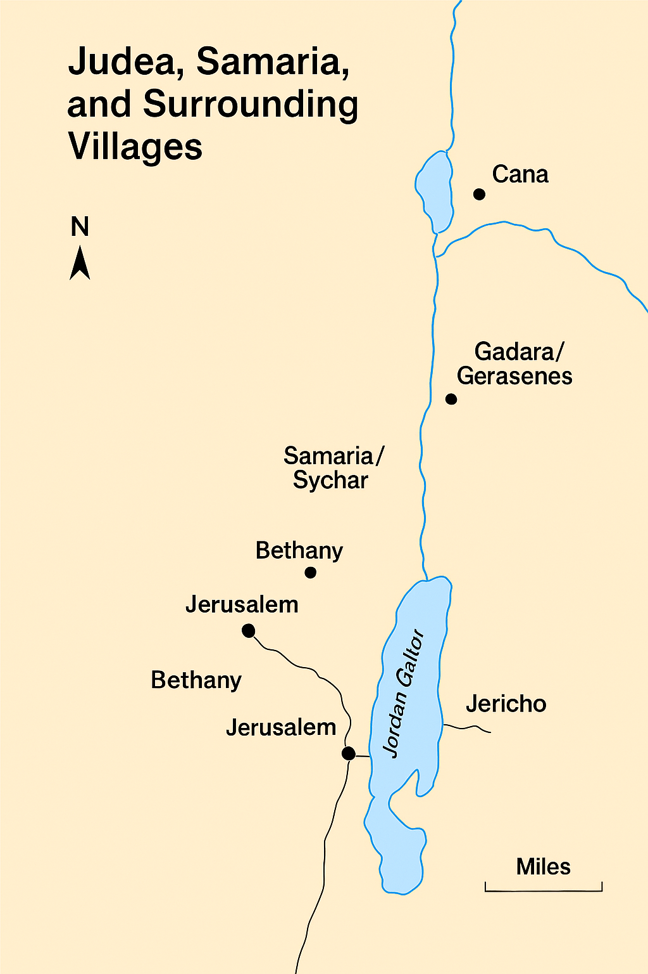
Discussion Questions
- Cultural impact of ministry in Samaria?
- Miracles in Judea vs Galilee.
- Significance of Zacchaeus encounter.
- Lessons from Emmaus journey.
Multiple Choice Quiz (Self-Scoring)
- In which town did Jesus read from Isaiah 61 in the synagogue?
  - a) Capernaum
  - b) Nazareth
  - c) Bethsaida
  - d) Nain
- Which city witnessed the healing of a paralytic on a mat?
  - a) Chorazin
  - b) Capernaum
  - c) Magdala
  - d) Cana
- Where did Jesus deliver the Sermon on the Mount?
  - a) Sea of Galilee
  - b) Bethsaida
  - c) Mount of Beatitudes
  - d) Nain
- Which village was Mary Magdalene healed from seven demons?
  - a) Bethsaida
  - b) Magdala
  - c) Cana
  - d) Chorazin
- In which location did Jesus raise a widow’s son?
  - a) Nain
  - b) Nazareth
  - c) Capernaum
  - d) Magdala
- Where did Jesus perform His first miracle?
  - a) Capernaum
  - b) Cana
  - c) Bethsaida
  - d) Chorazin
- Which city received woes from Jesus for their unbelief?
  - a) Nazareth
  - b) Chorazin
  - c) Bethsaida
  - d) Magdala
- Where did Jesus calm the storm and walk on water?
  - a) Sea of Galilee
  - b) Jordan River
  - c) Mount of Beatitudes
  - d) Nain
- Feeding of the 5000 occurred near which town?
  - a) Bethsaida Julias
  - b) Magdala
  - c) Cana
  - d) Chorazin
- Which town did Jesus call His own home in early ministry?
  - a) Cana
  - b) Nazareth
  - c) Bethsaida
  - d) Capernaum

Essay Assignment
Write a 100-word reflection on Jesus’ ministry in Judea, Samaria, and surrounding villages. Focus on lessons, cultural context, and God’s love.

Answer key for all multiple-choice questions for Parts 1 & 2 of Let’s Follow Jesus study guide:

Part 1: Northern & Central Galilee (10 Questions)
- a – Nazareth
- b – Capernaum
- b – Calmed storm and walked on water
- a – Mount of Beatitudes
- c – Nazareth
- a – Magdala
- a – Nain
- a – Cana
- a – Bethsaida Julias
- b – Bethsaida

Part 2: Judea, Samaria & Surrounding Villages (10 Questions)
- a – Samaria / Sychar
- b – Lazarus
- b – Jerusalem
- b – Zacchaeus
- b – His resurrection
- a – Jordan
- a – Gadara / Gerasenes
- b – End times prophecy
- b – Jericho
- a – Jerusalem

