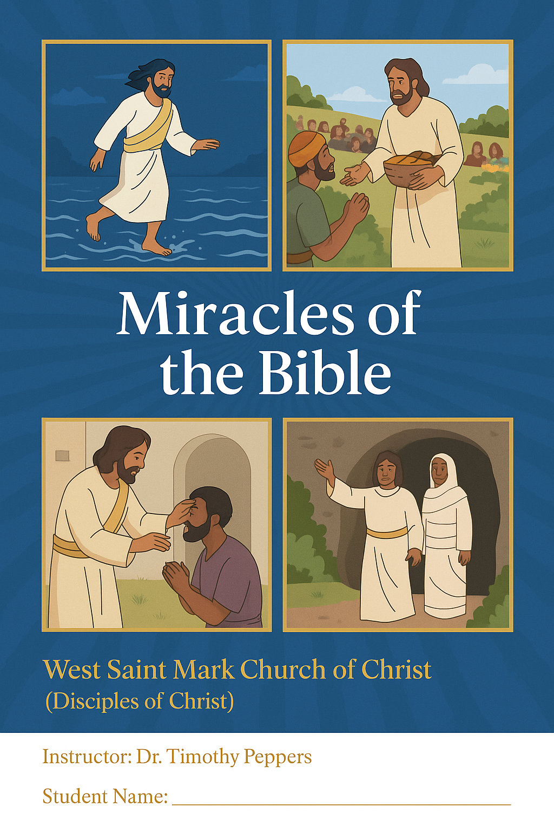
1. Lesson Objectives
By the end of this study, learners will:
- Identify major miracles recorded in the Bible.
- Understand the purpose of miracles in God’s plan for humanity.
- Analyze the spiritual and practical lessons behind each miracle.
- Reflect on the power, compassion, and authority of God as revealed in miraculous acts.
- Apply lessons from miracles to personal faith and daily life.

2. Lecture Notes / Highlights
Introduction:
Miracles are supernatural acts of God that reveal His power, glory, and love. They serve as signs to strengthen faith, teach spiritual truths, and demonstrate God’s intervention in human history.
Categories of Miracles:
- Creation Miracles: God’s acts of forming the universe (Genesis 1:1-31).
- Judgment and Deliverance: Events like the parting of the Red Sea (Exodus 14:21-22) demonstrating God’s power over nature and human oppressors.
- Provision Miracles: Daily needs met supernaturally, e.g., manna in the wilderness (Exodus 16:4-15).
- Healing Miracles: Restoration of sight, hearing, and health, e.g., healing the blind (John 9:1-12).
- Nature Miracles: Control over natural elements, e.g., calming the storm (Mark 4:35-41), walking on water (Matthew 14:25-33).
- Resurrection Miracles: Demonstration of power over death, e.g., Lazarus raised (John 11:38-44).
- Sign Miracles: Demonstrating God’s glory, e.g., water into wine at Cana (John 2:1-11).

Purpose of Miracles:
- Confirm the messenger of God (Hebrews 2:3-4)
- Strengthen faith in God’s authority
- Show God’s compassion for His people
- Teach lessons about obedience, trust, and reliance on God

3. Major Miracles with KJV References
Miracle | Scripture | Summary / Lesson
Creation | Genesis 1:1-31 | God created the universe and all living things. Demonstrates divine power and order.
Parting of the Red Sea | Exodus 14:21-22 | God delivers Israel from bondage. Lesson: Trust in God’s salvation.
Manna in the Wilderness | Exodus 16:4-15 | God provides sustenance. Lesson: Dependence on God daily.
Healing the Blind | John 9:1-12 | Jesus restores sight physically and spiritually. Lesson: Faith and spiritual perception.
Feeding the 5000 | John 6:1-14 | Jesus multiplies food. Lesson: God’s provision is abundant.
Walking on Water | Matthew 14:25-33 | Jesus demonstrates authority over nature. Lesson: Trust in God amidst fear.
Raising Lazarus | John 11:38-44 | Jesus demonstrates power over death. Lesson: Hope in eternal life.
Calming the Storm | Mark 4:35-41 | Jesus controls nature. Lesson: Peace through faith.
Healing the Leper | Matthew 8:2-3 | Jesus shows compassion and restores health. Lesson: God’s mercy.
Water into Wine | John 2:1-11 | Jesus performs His first public miracle. Lesson: Glory and blessing through obedience.
4. Multiple Choice Questions (Self-Scoring)
- Which miracle was Jesus’ first public miracle?
  - A) Healing the blind
  - B) Water into wine
  - C) Feeding the 5000
  - D) Walking on water
- God provided what for Israel in the wilderness?
  - A) Quail only
  - B) Water only
  - C) Manna and quail
  - D) Olive oil
- Who did Jesus raise from the dead?
  - A) Jairus’ daughter
  - B) Lazarus
  - C) Samuel
  - D) Elijah
- Which miracle demonstrated Jesus’ authority over nature?
  - A) Calming the storm
  - B) Healing the leper
  - C) Feeding the 5000
  - D) Water into wine
- The parting of the Red Sea is found in which book?
  - A) Genesis
  - B) Exodus
  - C) Leviticus
  - D) Numbers
- How many loaves did Jesus use to feed 5000 men?
  - A) 2 loaves and 5 fish
  - B) 5 loaves and 2 fish
  - C) 7 loaves
  - D) 12 loaves
- What did Jesus heal the blind man with?
  - A) Mud and spit
  - B) Water only
  - C) Oil
  - D) Prayers alone
- Which miracle foreshadowed resurrection?
  - A) Feeding the 5000
  - B) Raising Lazarus
  - C) Walking on water
  - D) Healing the leper
- What lesson is taught in the water-to-wine miracle?
  - A) Jesus is compassionate
  - B) Jesus reveals His glory
  - C) Celebration is sinful
  - D) Miracles are private
- Jesus walking on water encouraged the disciples to:
  - A) Doubt
  - B) Fear
  - C) Trust and believe
  - D) Walk themselves

6. Reflection Essay Assignment
Prompt: Write a 100-word essay reflecting on:
- Which miracle impacted you most and why
- What spiritual lesson you can apply to your life
- How miracles demonstrate God’s power and love

Answer Key: 1-B, 2-C, 3-B, 4-A, 5-B, 6-B, 7-A, 8-B, 9-B, 10-C

